Bexley Team News
St Barnabas, Joydens Wood
www.joydenswoodchurch.co.uk
St James, North Cray
www.stjamesnorthcray.org.uk
St John the Evangelist, Bexley
www.stjohnsbexley.org.uk
St Mary the Virgin, Bexley
www.stmarysbexley.co.uk

9th January 2022 Baptism of Christ / The First Sunday after Epiphany Issue 94

‘Face masks are now compulsory in Places of Worship (unless exempt)’
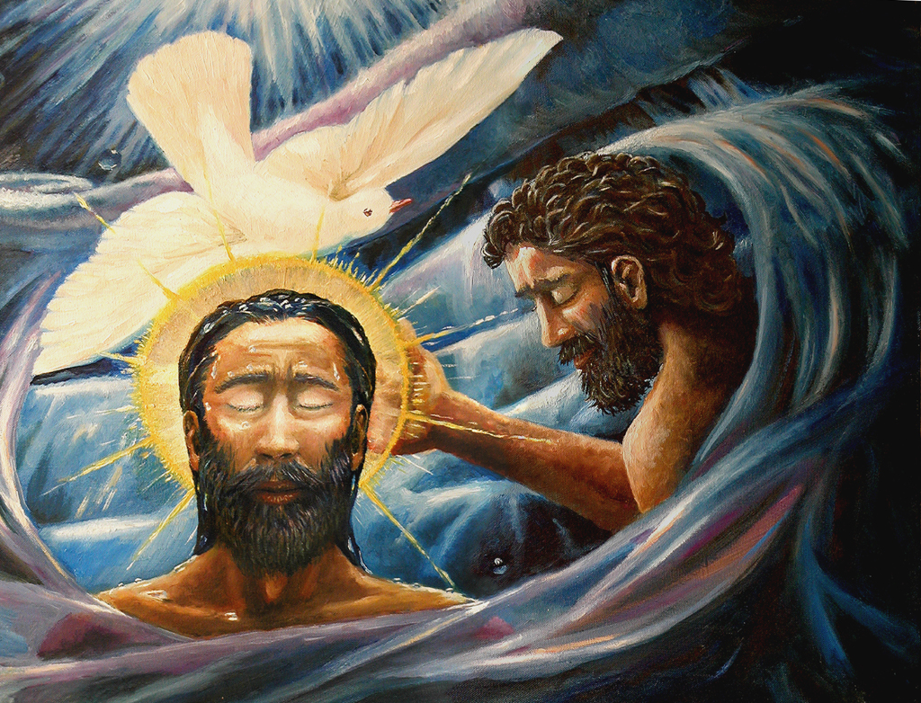
St. Mary’s 10.00 am Holy Communion
3.00 pm Messy Church in hall
Wednesday 10.00 am Holy Communion
St James 9.30 am Parade Service
St Barnabas 10.45 am Holy Communion
St John’s 8.00 am Holy Communion
10.00 am Holy Communion
Saturday 8th January
5.30 pm Nightwatch Zoom Service

Sunday 9th January
9.00 am Team Zoom
Service

Bible Readings Isaiah 43, v1-7 Acts 8 v14-17 Luke 3 v15-17, 21-22

The Collect Eternal Father, who at the baptism of Jesus revealed him to be your Son, anointing him with the Holy Spirit: grant to us, who are born again by water and the Spirit, that we may be faithful to our calling as your adopted children; through Jesus Christ your Son our Lord, who is alive and reigns with you, in the unity of the Holy Spirit, one God, now and for ever.

The Additional Collect Heavenly Father, at the Jordan you revealed Jesus as your Son: may we recognize him as our Lord and know ourselves to be your beloved children; through Jesus Christ our Saviour.

St John’s Sermons are posted each Sunday at fatheredwardbarlow.wordpress.com
Social media – engage with us via Facebook (/stjohnsbexley, Twitter (@stjohnsbexley) and Instagram (@stjohnsbexley)

Rev’d Matt is now putting his sermons on a blog which can be found here https://revmatthodder.blogspot.com/

THE BEXLEY TEAM CLERGY
Team Rector: Rev’d Canon Ren Harding renharding@hotmail.co.uk 01322 528923 07836644782
Associate Priest: Rev’d Sue Twynam setwynam@gmail.com 01322559501 07952468127
Team Vicar: Rev’d Edward Barlow fr.edwardbarlow@gmail.com 01322 521786
Team Vicar: Rev’d Clive Wood revclivewood@gmail.com 01322 270942 07982392809
Team Curate: Rev’d Matt Hodder matthodder10@gmail.com 07889873125

The Bexley Team Clergy

