Baptisms, weddings, funerals

Weddings
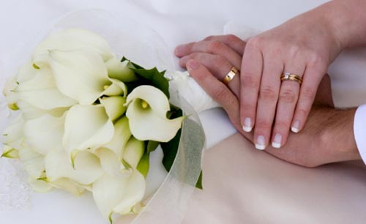
St Mary’s is a beautiful ancient church and a popular venue for weddings.
Initial enquiries should be made well in advance either by coming to the church for the 10am Sunday service or by contacting the Vicar.
A Service of Blessing following a civil wedding or on the occasion of a wedding anniversary or other special event can be arranged.
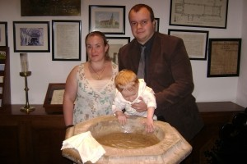
Christenings
Baptism (Christening) is a joyful event when a baby, young person or adult is received as a member of the Church.
It is usual for baptism to take place in the church of the parish where the child lives or at the church where the parents regularly attend. If you are not sure whether you live in St Mary’s parish, you can check at https://www.achurchnearyou.com/
When a baptism has been agreed, you are encouraged, if not already regular worshippers, to visit the church beforehand, perhaps at one of the Sunday services, such as the 10.00am Family Service on the fourth Sunday of each month. (check St. Mary’s website or LINK magazine for any occasional change to this pattern)
Once the baptism has been agreed the Vicar will arrange to meet with you a few weeks before to talk through the baptism service and baptism itself and answer any questions you may have. An alternative to Baptism is a service of thanksgiving for the gift of a child. This can be a good choice if you want to give thanks to God for your new arrival but are not yet ready to make the public promises to God that are made at a baptism.
Although there is no fee for a baptism some families like to support the upkeep of our ancient church building and support the ongoing mission of the church. This may be done by contributing to the offertory taken at the service or to the retiring collection at an afternoon baptism.
Further information on Baptism can be found at;
www.churchofengland.org/life-events/christenings

Further information on Thanksgiving for the Gift of a Child can be found at
https://churchofenglandchristenings.org/for-parents/thanksgiving-service/
The Vicar is always happy to talk with you about baptism and thanksgiving for the gift of a child.
We are also pleased to support older children and adults who are thinking about baptism – it’s never too late!
Please contact Revd. Clive with any baptism enquiries.

Communion before Confirmation for older children
If your children have reached years 5 or 6 in their primary education and would like to receive communion (the bread and wine) they can be prepared for that by the Vicar.

Confirmation

Confirmation completes your process of initiation as a full member of the Church.

When you are confirmed you receive the Holy Spirit as God’s seal on your spiritual journey through life. The special gifts received enable you to live out your life as a Christian.
Confirmation takes place at a public service with the Bishop who will invite you to renew your baptism promises and will pray for the gift of the Holy Spirit to come upon you.
If you would like to be confirmed or are thinking about it and would like further information please contact Mary Andrews, Churchwarden on 01322 523071.
Funerals
Please contact the Vicar, who will arrange a time with you and your family to plan a funeral service. Advice can be given about what to do, in what is often a sad and painful time for you, family and friends. We will try to meet your wishes which may include a church service.
St Mary’s holds an annual memorial service at which your loved one will be remembered. There is also a Remembrance Book that is always open in the church to which names can be added on payment of a fee.

